**Software Requirements Specification**

**Grade Sheet Generation Software**

**VERSION 3**

**Prepared by:**

**Saloni Goyal (16UCC083)**

**Priyansi Singh (16UCS143)**

**Parul Shandilya (16UCS126)**

**Anushka Prakash (16UCS223)**

**Table of Contents**

**Table of Contents 2**

**Revision History 3**

**1. Introduction 4**

1.1 Purpose

1.2 Document Conventions

1.3 Intended Audience and Reading Suggestions

1.4 Product Scope

1.5 References

**2. Overall Description 6**

2.1 Product Perspective

2.2 Product Functions

2.3 User Classes and Characteristics

2.4 Operating Environment

2.5 Design and Implementation Constraints

2.6 User Documentation

2.7 Assumptions and Dependencies

**3. External Interface Requirements 9**

3.1 User Interfaces

3.2 Hardware Interfaces

3.3 Software Interfaces

3.4 Communications Interfaces

**4. System Features 9**

4.1 System Feature 1

4.2 System Feature 2

**5. Other Nonfunctional Requirements 11**

5.1 Performance Requirements

5.2 Safety Requirements

5.3 Security Requirements

5.4 Software Quality Attributes

5.5 Business Rules

**6. Other Requirements 13**

**Appendix A: Glossary 13**

**Appendix B: Analysis Models 13**

**Appendix C: To Be Determined List 13**

**Revision History**

|  |  |  |  |
| --- | --- | --- | --- |
| **Name** | **Date** | **Reason For Changes** | **Version** |
| **Grade Sheet Generation srs** | 26 Aug 2018 | Initial Preparation | 1 |
| **Grade Sheet Generation srs updated** | 2 sep 2018 | Added Business rules and few more changes | 2 |

# Introduction

## 1.1 Purpose

The purpose of this SRS document is to specify software requirements of the proposed system.

This software package is developed from scratch exclusively for the LNMIIT in order to:

* Automate the calculation of CPI and generation of grade sheet and transcript.
* Enable the student to view grade sheet and transcript online and subsequently know the percentile by themselves through secure internet-based access to LNMIIT ’s Grade Sheet Generation software package.
* Enable the students to find the minimum SGPA required to move up a pointer threshold.
* Easing student and AR Academic work related to marks and grade distribution and issues related to this.
* To reduce the overall turn-around time to generate grade sheet and transcript .

## 1.2 Document Conventions

The following documentation conventions are followed in preparing this SRS:

1. The priority of a requirement is specified at the end of that requirement in curly braces and using the notation { Priority : nn}, where ‘nn’ is an integer in the range 00 (lowest priority) to 99 (highest priority).
2. **Personal details:** Details of candidate such as name, qualification, phone number, address, e-mail address etc.
3. **HTML:** Hypertext Markup Language is a markup language used to design static web pages.
4. **JSP:** Java Server Page.
5. **SQL:** Structured Query Language

## 1.3 Intended Audience and Reading Suggestions

This document is created for:

1. The AR Academic for reviewing and approval at appropriate times.
2. The software development team for their use in analyzing the requirements.

## 1.4 Product Scope

This project’s aim is to automate grade sheet generation. The data used by the system is stored in a database that will be the centre of all information held about students and exams.

1. To enable the LNMIIT students to securely access this Grade Sheet generation software package using internet in order to generate grade sheet, subsequently know the pointer required in next semester to achieve a particular pointer target and to know the percentile.
2. To cater to ALL types of grade related query by the LNMIIT students.
3. To cater to all activities of grades and marks management, viz, validation of final grade sheet.
4. To cater to all the students of all the Department of the LNMIIT .
5. To view grades details of the students.

## 1.5 References

The following reference manuals of the LNMIIT and its guidelines from the Administrative Section are used in preparing this SRS:

1. Minutes of the Meeting from the Academic Council Meeting, which was attended by the representatives from the Administration, faculty members and student representatives
2. Minutes-of-the-Meeting between the software development team and management staff from the LNMIIT.

# 

# 

# 

# 

# 

# 2.Overall Description

## 2.1 Product Perspective

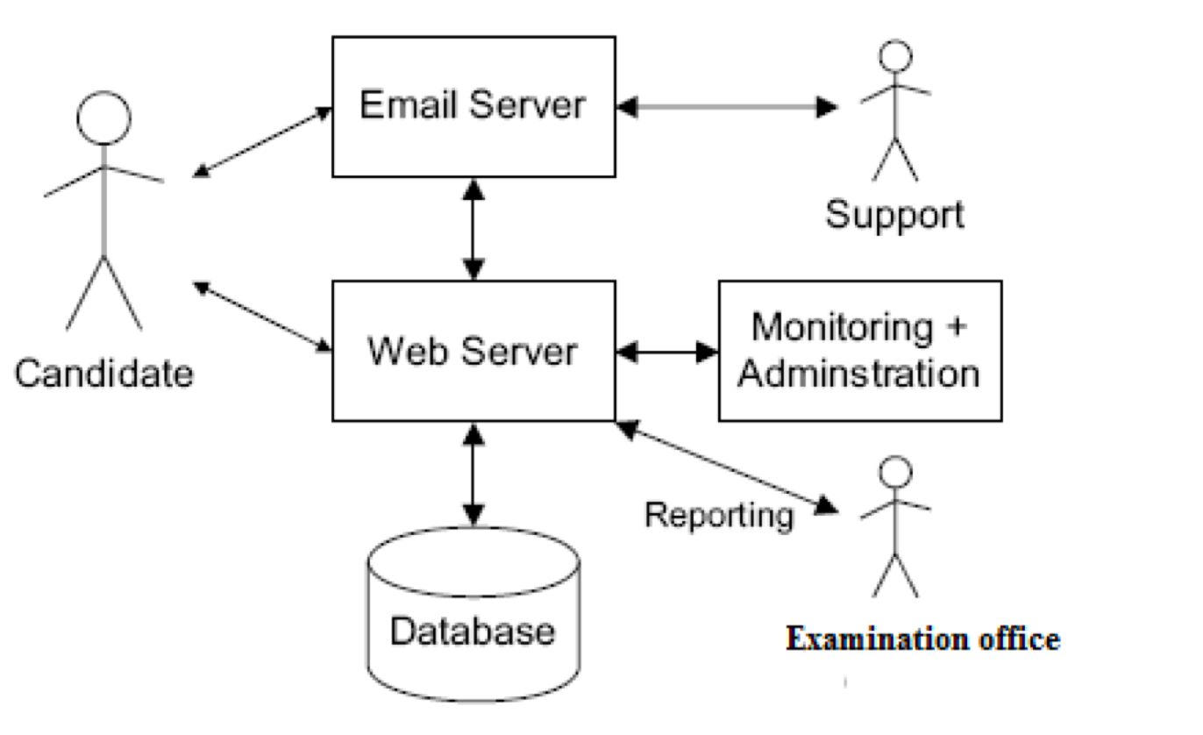

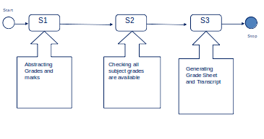

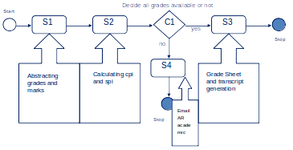

## 2.2 Product Functions

This software package is expected to offer the following services:

1. For AR Academic of LNMIIT:

Facility to view the grade sheets and transcript of students and print them.

2. For the Students of LNMIIT:

Facility to view the grade sheet, transcript, percentile score, the minimum SGPA required to move up a pointer threshold.

## 2.3 User Classes and Characteristics

This software package will be used by two categories of users:

**Students of the LNMIIT:** These users will use this software package to find out marks obtained, whether they are eligible to get BTech degree ,to generate their grade sheet and transcript and to calculate their percentile score and the minimum SGPA required to move up a pointer threshold .

**AR Academic:** These users will use this software package to generate the grade sheets and transcript.

## 2.4 Operating Environment

The software is expected to work in the following environments:

* MS Windows 7 and above
* MS Windows based Server OS
* MySQL

## 2.5 Design and Implementation Constraints

1. GUI is only in plain English.
2. Login and password is used for identification of authorized persons.
3. No checks of time line are being implemented.

## 2.6 User Documentation

## This software package comes with a short documentation which outlines its utility and functions *.*

1. The details of the (i) Analysis(ii) Design and (iii) Test Cases of this software package will be delivered along with this software.

## 2.7 Assumptions and Dependencies

The assumptions made are :

1. The faculty members have already uploaded the grades of students registered in their respective courses. And if not, they will be reminded by AR Academic.
2. The faculty members have uploaded correct grades of students.
3. The faculty members can’t change the grades once locked.

# 3. External Interface Requirements

# 3.1 User Interfaces

1. **End User:** - Every user should be comfortable of working with computer and net browsing. She/he must have basic knowledge of English too.
2. **Administrators: -** Authorized by Institution to maintain Security.

## 3.2 Hardware Interfaces

**Client Side**

**Processor : Pentium-IV**

**RAM : 8 GB**

**Hard Disk : 1 TB HDD 128 GB SSD**

**Server Side**

**Processor : Pentium-IV**

**RAM : 2GB**

**Hard Disk : 320GB**

## 3.3 Software Interfaces

**Client on Internet:** Web Browser, Operating System

**Client on Intranet:** Client Software, Web Browser, Operating System

**Web Server:** Tomcat, Operating System

## 3.4 Communications Interfaces

This software should be securely accessible through wired and unwired internet communication channels from both inside and outside the campus.

# 4. System Features

The requirements of this software package are described per each category of User:

1. *Students of the institute*
2. *AR Academic*

**4.1 Requirements of the Students**

4.1.1 Description and Priority

* View grades
* View transcript
* Download grade sheet
* Download transcript
* View percentile score
* View the minimum SGPA required to move up a pointer threshold.

4.1.2 Stimulus/Response Sequences

|  |  |  |
| --- | --- | --- |
| S. No. | Stimulus from the user | Response from the software |
| 1. | Student logs in using the user ID and password | Software will validate the user-id  and password;  Software will display the Initial Screen |
| 2. | Student selects “View Grade sheet” option | The latest grade sheet of the student is displayed on the screen, with updated CPI |
| 3. | Student selects “Download Grade Sheet” option | A dialog box opens, asking the student to select the directory where they want to save the grade sheet |
| 4. | Student selects “View Transcript” option | The up to date transcript of the student is displayed on the screen |
| 5. | Student select “Download Transcript” | A dialog box opens, asking the student to select the directory where they want to save the grade sheet |
| 6. | Student select “GPA Required Calculator” | A dialog box opens, asking the student their target cgpa and displaying sgpa required for next sem. |
| 7. | Student select “Percent Calculator” | Percentile of the student is shown. |

4.1.3 Functional Requirements

As per the above table.

**4.2 Requirements of the AR Academic**

4.2.1 Description and Priority

* Generate grade sheets branch wise and year wise
* Generate transcripts branch wise and year wise
* View if all the faculty members have uploaded and locked their respective grade lists
* Send reminder to faculty members who have not submitted or locked the grade lists
* View percentile score
* View the minimum SGPA required to move up a pointer threshold.

4.2.2 Stimulus/Response Sequences

|  |  |  |
| --- | --- | --- |
| S. No. | Stimulus from the user | Response from the software |
| 1. | Administration logs in using the master id and password | Software will validate the user-id  and password;  Software will display the Initial Screen |
| 2. | Selects the “Student ” option | AR Academic can select gradesheet option to generate gradesheet and transcript generation to generate transcript |
| 3. | Selects the “Generate Transcripts” option | AR Academic can select the year and branch of students they want to generate transcripts for and do it in one go; |
| 4. | Selects “Check Status of Grade Lists” option | Can see the list of faculty and check if they have uploaded and locked the grade lists for their respective subjects or not |
| 5. | Selects “Send reminder” option | Can send a reminder to the concerned faculty members |

4.2.3 Functional Requirements

As per the above table.

# 5. Other Nonfunctional Requirements

## 5.1 Performance Requirements

Some Performance requirements identified is listed below:

* The database shall be able to accommodate a minimum of 2500 records of students.
* The software shall support use of multiple users at a time.
* Grade sheets and transcripts shall be generated without any discrepancy.

## 5.2 Safety Requirements

* Students shall be allowed to only view the grade sheet.
* No user shall be allowed to alter any database.

## 5.3 Security Requirements

* Authentic login to AR Academic and Students
* Assign certain functions to different modules

## 5.4 Software Quality Attributes

1. **Availability :**

* All cached data will be rebuilt during every start-up. There is no recovery of user data if it is lost. Default values of system data will be assigned when necessary.

**2. Usability :**

Some of the usability requirements identified for this system are listed below:

* A logical interface is essential to an easy to use system, speeding up common tasks.
* Error prevention is integral to the system and is provided in a number of formats from sanity checks to limiting free-text input.

**3.** **Reliability**

Some of the attributes identified for the reliability is listed below:

* All data storage for user variables will be committed to the database at the time of entry.
* Data corruption is prevented by applying the possible backup procedures and techniques.

**4.**  **Maintainability**

* The user will be able to reset all options and all stored user variables to default settings.

**5**. **Portability Requirements**

Some of the attributes of software that relate to the ease of porting the software to other host machines and/or operating systems. This may include:

* Java is used to develop the product. So it is easiest to port the software in any environment.

## 5.5 Business Rules

* If grades are not available for any course , the grade sheet will not be generated.
* If any student gets an ‘I’ grade, his grade points in that course will be considered as zero.

# 

# 6.Other Requirements

NONE

**Appendix A: Glossary**

PE: Program Elective

OE: Other Elective

CSE:Computer Science and Engineering

CCE: Communication And Computer engineering

ECE: Electronic and Communication Engineering

ME: Mechanical Engineering

**Appendix B: Analysis Models**

We use data flow diagrams, class diagrams, state-transition diagrams, and entity-relationship diagrams to study and analyse the software

**Appendix C: To Be Determined List**

NIL

# 